* Copyright for test papers and marking guides remains with *West Australian Test Papers*.
* The papers may only be reproduced within the purchasing school according to the advertised conditions of sale.
* Test papers must be withdrawn after use and stored securely in the school until 14th October 2019.

**PHYSICS**

**UNITS 3 & 4**

**2019**



**Insert School Logo**

Name: _______________________________________________________

Teacher: ___________________________________________________

***TIME ALLOWED FOR THIS PAPER***

Reading time before commencing work: Ten minutes

Working time for the paper: Three hours

***MATERIALS REQUIRED/RECOMMENDED FOR THIS PAPER***

**To be provided by the supervisor:**

* This Question/Answer Booklet; Formula and Constants sheet

**To be provided by the candidate:**

* Standard items: pens, pencils, eraser or correction fluid, ruler, highlighter.
* Special items: Calculators satisfying the conditions set by the SCSA for this subject.

***IMPORTANT NOTE TO CANDIDATES***

No other items may be taken into the examination room. It is **your** responsibility to ensure that you do not have any unauthorised notes or other items of a non-personal nature in the examination room. If you have any unauthorised material with you, hand it to the supervisor **before** reading any further.

**Structure of this paper**

|  |  |  |  |  |  |
| --- | --- | --- | --- | --- | --- |
| Section | Number of questions available | Number of questions to be answered | Suggested working time  (minutes) | Marks available | Percentage of exam |
| Section One:  Short answer | 13 | 13 | 50 | 54 | 30 |
| Section Two:  Extended answer | 7 | 7 | 90 | 90 | 50 |
| Section Three:  Comprehension  and data analysis | 2 | 2 | 40 | 36 | 20 |
|  |  |  | **Total** | 180 | 100 |

**Instructions to candidates**

1. The rules for the conduct of Western Australian external examinations are detailed in the *Year 12 Information Handbook 2019.* Sitting this examination implies that you agree to abide by these rules.
2. Write your answers in this Question/Answer Booklet.
3. When calculating numerical answers, show your working or reasoning clearly. Give final answers to **three** significant figures and include appropriate units where applicable.

When estimating numerical answers, show your working or reasoning clearly. Give final answers to a maximum of **two** significant figures and include appropriate units where applicable.

1. You must be careful to confine your responses to the specific questions asked and follow any instructions that are specific to a particular question.
2. Spare pages are included at the end of this booklet. They can be used for planning your responses and/or as additional space if required to continue an answer.
   * Planning: If you use the spare pages for planning, indicate this clearly.
   * Continuing an answer: If you need to use the space to continue an answer, indicate in the original answer space where the answer is continued, i.e. give the page number. Refer to the question(s) where you are continuing your work.

**Section One: Short response 30% (54 Marks)**

This section has **thirteen** **(13)** questions. Answer **all** questions. Write your answers in the space

provided. Suggested working time for this section is 50 minutes.

**Question 1 (4 marks)**

Mars’ mass is 6.39 × 1023 kg and has an orbital radius around the Sun of 228 million kilometres. Calculate the weakest gravitation force that can act between Earth and Mars, assuming both Earth and Mars have circular orbits.

Answer: __________________ N

**Question 2 (4 marks)**

An electron with 2.80 eV of kinetic energy bombards an atom with a single ground state electron. The atom’s electron is excited and later transitions back to the ground state, emitting a single 518 nm photon. Calculate the kinetic energy of the bombarding electron after it scattered off the atom.

Answer: __________________ eV

**Question 3 (4 marks)**

A 30.0 g golf ball at a mini golf course approaches a small vertical loop obstacle at 3.45 m s-1. The ball follows the track, completing the vertical loop.

3.45 m s-1

0.400 m

Calculate the magnitude of the reaction force applied to the ball by the track when the ball is at the top of the loop.

Answer: __________________ N

**Question 4 (4 marks)**

The diagram below shows an electron entering a uniform 2.00 N C-1 electric field. There is also a magnetic field in this region (not shown on the diagram).

Electron Velocity

Electric Field

The electron has a constant velocity of 8540 m s-1 while in the presence of the two fields. State the direction of the magnetic field and calculate its strength.

Direction: __________________ Strength: __________________ T

**Question 5 (4 marks)**

Mary observes a spaceship moving at 0.800c to have a 32.0 m length along the direction of its velocity. Quinn sees this spaceship moving at 0.450c along the same direction as Mary. Calculate the length of the spaceship as seen by Quinn.

Answer: __________________ m

**Question 6 (4 marks)**

The following particle reaction is proposed by a PhD student while studying new, exotic particles of the standard model.

$$udb→c\overline{c}+s\overline{u}+uud$$

Justify whether this reaction is possible based on baryon number and electric charge.

**Question 7 (4 marks)**

A square coil moves into a uniform 260 mT magnetic field which is aligned perpendicular to the area of the coil. The coil is induced with a 0.650 V emf as it enters the field at 4.75 m s-1. For what amount of time does the coil have an induced emf?

X X X

X X X

X X X

X X X

Answer: __________________ s

**Question 8 (4 marks)**

Victor, an amateur rocketeer, performs a calculation showing the amount of work the combustion of the rocket fuel needs to do to the rocket to get it to the upper atmosphere from the surface of the Earth. Victor assumes the work is $W=∆E=mgh$ where $m$ is the mass of the rocket, $g$ is 9.80 m s-2 and is the altitude the rocket needs to reach. Describe two issues with Victor’s method for determining the work required.

**Question 9 (4 marks)**

Describe how an operating coloured LED and a voltmeter could be used to estimate Planck’s constant. Include the measurements or data that would need to be obtained and any calculations required.

**Question 10 (4 marks)**

A diagram of a simple AC generator is shown below.

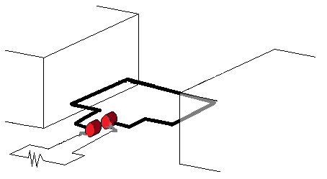

1. Label the two components indicated in the diagram by writing in the two boxes provided.

(2 marks)

1. Describe the role each of these two labelled components play in the operation of the generator. (2 marks)

**Question 11 (4 marks)**

An induction hotplate first converts the 50.0 Hz electrical supply, common to households in Australia, into a new frequency. By referring to physical principles, explain the benefit of the frequency change and whether the frequency is increased or decreased.

**Question 12 (4 marks)**

The redshift of light from galaxies not our own is supporting evidence of the Big Bang Theory. Describe what causes the increasing amount of redshift of light from galaxies further away and also describe why **only** nearby galaxies may have blueshifted light.

**Question 13 (6 marks)**

A motorbike is using a 16.00 banked curve to assist with making a turn with a 35.0 m radius at 60.0 km h-1. While the road supplies a normal force of 1280 N, the wheels of the motorbike supply an additional 185 N frictional force, along the plane of the surface, to assist with making the corner.

1. Draw a vector diagram which shows all the physical forces acting on the motorbike in this scenario and the resulting net force. (2 marks)
2. Calculate the centripetal force acting on the motorbike. (4 marks)

Answer: __________________ N

**End of Section One**

**Section Two: Problem-solving 50% (90 Marks)**

This section has **seven (7)** questions. You must answer **all** questions. Write your answers in the

space provided. Suggested working time for this section is 90 minutes.

**Question 14 (13 marks)**

The equipment below is used in an experiment to test the particle nature of light.

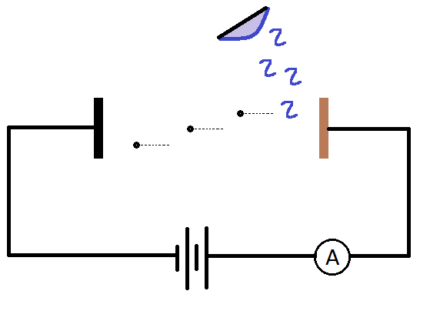

X

Y

Z

1. The part “Y” is the monochromatic light. Name and describe the function of the parts labelled “X” and “Z” (4 mark)

|  |  |  |
| --- | --- | --- |
| Label | Name | Description of function/behaviour |
| X |  |  |
| Z |  |  |

1. Describe what the “work function” means in the context of this experiment. (2 marks)
2. To test for the particle nature of light, the light source is monochromatic (i.e.: consisting of a single colour). Explain why this is important for this experiment. (3 marks)
3. Calculate the minimum voltage required between the two plates to ensure the ammeter detects zero current when the wavelength of the incident light is 345 nm and the work function is 1.50 eV. (4 marks)

Answer: __________________ V

**Question 15 (10 marks)**

A 25.0 kg sign is hung by connecting two wires of negligible mass, as shown in the diagram below.

Don’t Read This Sign!

30.00

50.00

T1

T2

1. Calculate the tensions T1 and T2 by use of a vector diagram. (4 marks)

T1: __________________ N T2: __________________ N

1. Given the sign has a horizontal length of $L$, at what proportion of $L$ as measured from the left side of the sign is the centre of mass? (3 marks)

Answer: __________________

1. As the angle made by T2 and the horizontal decreases, explain what happens to the value of T1 and T2. (3 marks)

**Question 16 (12 marks)**

Claire is standing on Earth. She observes Jim passing by in a spaceship at 0.60 c. Jim observes the spaceship to be 18.0 m long. Jim is playing hyperspace pong where he hits a ball towards the front of the spaceship from the back at 0.40 c (according to Jim). The ball has a rest mass of 0.500 kg.

1. What time does Jim observe the ball take to reach the front of the spaceship?

(2 marks)

Answer: __________________ s

1. As the ball completes the journey towards the front of the spaceship, does Jim observe the proper length of the ball’s journey or the proper time for the ball’s journey or both? Justify your choice.

(2 marks)

1. How long is the spaceship as measured by Claire? (2 marks)

Answer: __________________ m

1. What is the velocity of the ball as measured by Claire? Give your answer as a fraction of the speed of light. (2 marks)

Answer: __________________ c

1. Calculate the energy of the ball as measured by Jim. (2 marks)

Answer: __________________ J

1. Calculate the momentum of the ball as measured by Claire. (2 marks)

Answer: __________________ kg m s-1

**Question 17 (12 marks)**

A trebuchet is a siege weapon that flings boulders from a great distance. Consider the arrangement of a trebuchet and a castle shown below.

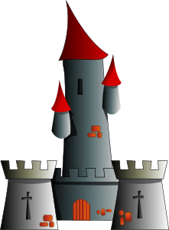

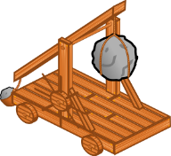

$$s_{h}=326 m$$

1. The boulder lands at the same height it was launched from, was fired at 45.00 above the horizontal and was airborne for 8.16 s. Complete the following questions:
   * 1. Calculate the launch velocity of the boulder. (3 marks)

Answer: __________________ m s-1

* + 1. Calculate the maximum height the boulder achieved above its launch point. (3 marks)

Answer: __________________ m s-1

Medieval castles were often built at higher elevations to give an advantage to those under siege.



$$s_{v}=50.0 m$$

$$s_{h}=326 m$$

1. A launched boulder is in the air for 4.80 s. The distances, $s_{h}$ and $s_{v}$ above indicate how far the boulder travelled to hit the castle. Determine both the speed and angle above the horizon the boulder was launched at. You may make use of the trigonometric identity $tanθ=\frac{sinθ}{cosθ}$ and air resistance can be ignored. (6 marks)

Speed: __________________ m s-1 Angle: __________________ 0

**Question 18 (11 marks)**

Transmission of radio waves by an antenna is intrinsically polarised. An AC voltage is supplied to the antenna which generates the radio waves, with a polarisation matching the orientation of the conducting metal of the antenna. Receiving antennae, like those on the roofs of most homes, must have the same orientation to receive a strong signal – the wrong orientation won’t pick up the radio wave.

Each television network sends out a channel’s picture and sound data via radio waves. A television has electronic components that can isolate the data from a single frequency of radio wave. Each television network has **one** frequency they are allowed to transmit over.

1. Describe how an AC voltage applied to a conductor can produce electromagnetic waves. Describe why an equivalent DC voltage could not. (3 marks)
2. Compare polarised light and unpolarised light. (2 marks)
3. Some satellite television networks will transmit two different channels over the same frequency. To achieve this, both the television network transmission antenna and the household receiving antenna must have a conductor with a horizontal orientation and another with a vertical orientation
   1. By referring to physical behaviour of waves, describe why it would generally be an issue if a frequency of radio wave had more than a single channel broadcast on it. (3 marks)
   2. Explain how two channels of a satellite television network can be on the same frequency without the issue of part (i) being a concern. (3 marks)

**Question 19 (14 marks)**

The Large Hadron Collider is the largest synchrotron in the world, with a total circumference of 26.7 km. While capable of accelerating protons up to 6.50 TeV, first operations in 2013 were run at the relatively lower 3.50 TeV. The Large Hadron Collider has multiple stages of particle accelerators, starting with a simple linear accelerator and eventually confining the proton beam in the main ring. Very powerful, expensive magnets, powered and cooled to near absolute zero are required to confine the beam.

1. Describe how a magnetic field can help keep protons confined within the ring of a synchrotron. (3 marks)
2. Explain why the protons in the Large Hadron Collider must first be accelerated in a straight line, with a linear accelerator, rather than starting in a ring like in the synchrotron.

(2 marks)

1. What percentage of the energy of the proton beam used in 2013 is due to the rest mass of the proton? (3 marks)
2. Explain a benefit of making the confinement ring so large. (3 marks)
3. Describe how the Large Hadron Collider is used to make new scientific discoveries.

(3 marks)

**Question 20 (18 marks)**

A pair of students entering a STEM competition proposed a method of determining the magnetic flux density of a uniform magnetic field. The students took a 30.0 cm long, straight conductor and attached either end to a voltmeter. The conductor was pushed into a uniform field while the voltmeter remained in place.

1. Explain why a voltage is measured as the conductor moves through the field.

(2 marks)

The velocity of the conductor was carefully controlled just prior to the conductor entering the field and the accompanying voltmeter reading was recorded over multiple trials. The students estimated their velocity measurements had a ±10% uncertainty while the voltage measurements had negligible uncertainty.

|  |  |  |
| --- | --- | --- |
| Velocity (m s-1) | Velocity Uncertainty (m s-1) | Voltage (mV) |
| 1.00 | ± 0.1 | 75 |
| 1.50 |  | 110 |
| 2.00 |  | 150 |
| 3.00 |  | 240 |
| 4.00 |  | 350 |

1. Complete the table by adding the absolute uncertainty of the velocity measurements.

(2 marks)

1. Produce a graph, using the grid provided on the next page, to show the relationship between the voltage and the velocity. The velocity needs to be placed on the horizontal axis. Include error bars and a line of best fit. (5 marks)

prac exam youngs mod 10 by 10

1. Calculate the gradient of the line of best fit. (2 marks)

Answer: __________________ T m

1. Using the gradient and any other necessary data, calculate the magnetic flux density of the uniform field. (2 marks)

Answer: __________________ T

1. The students found that the voltage reading decreased the longer the bar was moving through the field – so the students recorded the voltage when the conductor was in the middle of the uniform field.
   1. In addition to air resistance and friction, explain the other cause of the change in the voltage reading. (2 marks)
   2. If the students had instead taken the voltage measurement soon after the conductor entered the field, how would their determination of the flux density differ from the result calculated part (e)? Justify your response. (3 marks)

**End of Section 2**

**This page has been left blank intentionally**

**Section Three: Comprehension 20% (36 Marks)**

This section contains **two (2)** questions. You must answer both questions. Write your answers in

the spaces provided. Suggested working time for this section is 40 minutes.

**Question 21 (18 marks)**

# *The Universe Has A Speed Limit, And It Isn’t The Speed Of Light*

When it comes to speed limits, the ultimate one set by the laws of physics themselves is the speed of light. Moreover, anything that’s made of matter can only approach, but never reach, the speed of light. If you don’t have mass, you must move at the speed of light; if you do have mass, you can never reach it. But practically, in our Universe, there’s an even more restrictive speed limit for matter, and it’s lower than the speed of light. Here’s the scientific story of the real cosmic speed limit.

When scientists talk about the speed of light — 299,792,458 m/s — we implicitly mean “the speed of light in a vacuum.” Only in the absence of particles, fields, or a medium to travel through can we achieve this ultimate cosmic speed. Even at that, it’s only the truly massless particles and waves that can achieve this speed. This includes photons, gluons, and gravitational waves, but not anything else we know of. But there’s no such thing, practically, as a perfect vacuum. Even in the deepest abyss of intergalactic space, there are three things you absolutely cannot get rid of.

1. The WHIM: the warm-hot intergalactic medium. This tenuous, sparse plasma are the leftovers from the cosmic web. While some matter clumps into stars and galaxies, other matter remains in the great voids of the Universe. Starlight ionizes these atoms, creating a plasma that may make up about 50% of the total normal matter in the Universe.
2. The CMB: the cosmic microwave background. This leftover bath of photons originates from the Big Bang, where it was at extremely high energies. Even today, at temperatures just 2.7 degrees above absolute zero, there are over 400 CMB photons per cubic centimetre of space at an average energy of 0.00023 eV per photon.
3. The CNB: the cosmic neutrino background. The Big Bang, in addition to photons, creates a bath of neutrinos. Outnumbering protons by perhaps a billion to one, many of these now-slow-moving particles fall into galaxies and clusters, but many remain in intergalactic space as well.

Any particle traveling through the Universe will pass through particles from the WHIM, neutrinos from the CNB, and photons from the CMB.

The Large Hadron Collider accelerates particles here on Earth up to a maximum velocity of 299,792,455 m/s, or 99.999999% the speed of light. The highest-energy cosmic rays have approximately 36 million times the energy of the fastest protons ever created at the Large Hadron Collider. Assuming that these cosmic rays are also made of protons gives a speed of 299,792,457.99999999999992 m/s, which is extremely close to, but still below, the speed of light in a vacuum. There’s a very good reason that, by time we receive them, these cosmic rays aren’t more energetic than this.

If there is a particle with energies in excess of 5.00 × 10¹⁹ eV, they can only travel a few million light years — max — before a photon from the CMB, interacts with it. When that interaction occurs, there will be enough energy to produce a neutral pion, which steals energy away from the original particle, following from $E=mc^{2}$.

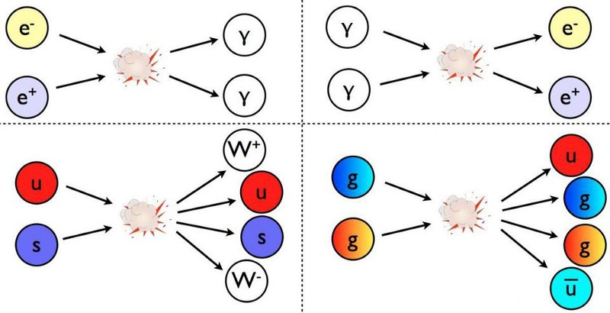

The more energetic your particle is, the more likely you are to produce pions, which you’ll continue to do until you fall below this theoretical cosmic energy limit of 5.00 × 10¹⁹ eV, known as the [GZK cutoff](http://en.wikipedia.org/wiki/Greisen-Zatsepin-Kuzmin_limit).

We believe that every charged particle in the cosmos — every cosmic ray, every proton, every atomic nucleus — should be limited by this speed. Not just the speed of light, but a little bit lower, thanks to the leftover glow from the Big Bang and the particles in the intergalactic medium. If we see anything that’s at a higher energy, then it either means:

1. particles at high energies might be playing by different rules than the ones we presently think they do,
2. they are being produced much closer than we think they are: within our own Local Group or Milky Way, rather than these distant, extragalactic black holes,
3. or they’re not protons at all, but composite nuclei.

The few particles we’ve seen that break the GZK barrier are indeed in excess of 5 × 10¹⁹ eV, in terms of energy, but do not exceed 3 × 10²¹ eV, which would be the corresponding energy value for an iron nucleus. Since many of the highest-energy cosmic rays have been confirmed to be heavy nuclei, rather than individual protons, this reigns as the most likely explanation for the extreme ultra-high-energy cosmic rays.

There is a speed limit to the particles that travel through the Universe, and it isn’t the speed of light. Instead, it’s a value that’s very slightly lower, dictated by the amount of energy in the leftover glow from the Big Bang. As the Universe continues to expand and cool, that speed limit will slowly rise over cosmic timescales, getting ever-closer to the speed of light. But remember, as you travel through the Universe, if you go too fast, even the radiation left over from the Big Bang can fry you. So long as you’re made of matter, there’s a cosmic speed limit that you simply cannot overcome.

1. Name three things in the Universe that can move at the cosmic speed limit and describe the requirements to reach the cosmic speed limit. (3 marks)
2. A neutral pion has a rest mass of 135 MeV/c2. Calculate the minimum number of neutral pions that need to be produced by a 5.03 × 1019 eV particle to reduce to the cosmic energy limit. (3 marks)
3. The article compares the Large Hadron Collider and cosmic rays. Protons in the Large Hadron Collider are accelerated up to 6.50 TeV. What is the energy of the most energetic cosmic rays in eV? (2 marks)

Answer: __________________ eV

1. Calculate the average frequency of a photon from the CMB (3 marks)

Answer: __________________ Hz

1. Explain why the interaction of a very energetic particle with a photon can cause the particle to slow down. (3 marks)
2. Describe which of the three reasons given in the article is the most likely cause when we have detected particles more energetic than the GZK barrier. (3 marks)

**Question 22 (18 marks)**

# *Brushed and Brushless DC Electric Motors*

In this course you were introduced to the DC electric motor. An emf source drives a current through an armature coil, in the presence of a magnetic field, which produces a torque. Brushes and a commutator are used to ensure the direction of rotation is maintained. The motor then produces mechanical energy which is transferred to a load (the thing that we want to spin). This motor design was first used over 100 years ago but there are now many variations of motors, each with their own advantages and disadvantages.

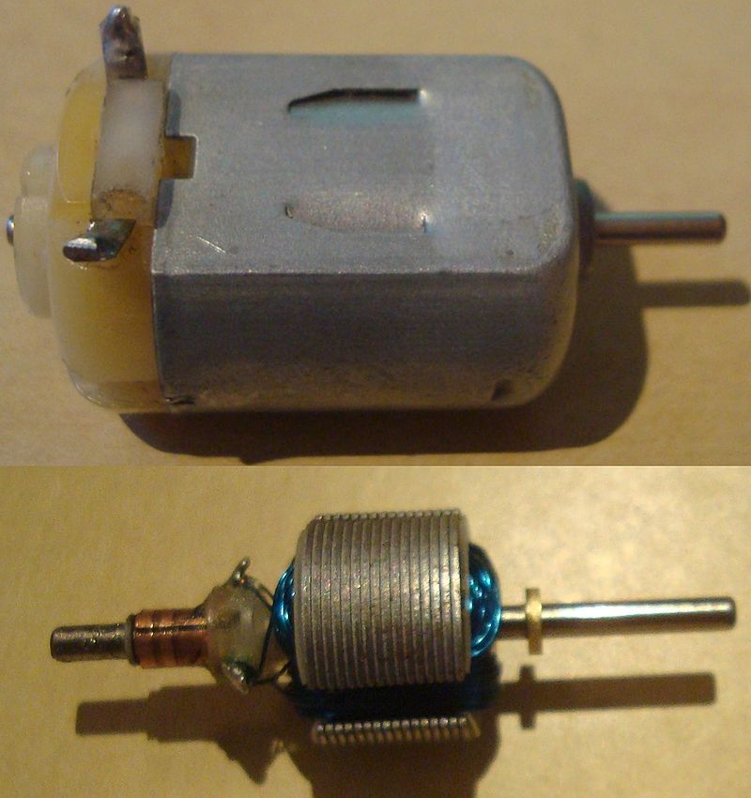The motor you are most familiar with from this course is referred to as a brushed DC motor. It is powered by a DC emf source and, as mentioned before, requires brushes and a commutator to operate. These motors are still used today. The smallest examples are found in toy cars and battery-operated fans. Being so small, a permanent magnet suffices to create the magnetic field required.

Larger brushed DC motors are used in printing presses. The size of these motors makes using a permanent magnet impractical. An electromagnet is used to produce the magnetic field, which can be powered by the same emf source that drives the current through the armature coil. These electromagnets are referred to as field coils – as in the coils in a motor responsible for producing the magnetic field. There are two methods by which the emf source can be connected to both the armature coils and field coils. Diagram A below is for a shunt wound DC motor and Diagram B is a series wound DC motor.

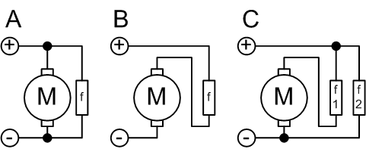

A: Shunt wound

B: Series wound

M is the armature coil, f is the field coil

A shunt wound design has the field coils in parallel with the armature coils. Both coils receive the same voltage from the emf source. When electric voltage is supplied to the shunt DC motor, due to high resistance of the shunt winding, it draws very low current. The higher number of turns of the field coil helps in generating a strong magnetic field. The armature draws a high current, thus needs thicker wires. A shunt DC motor is naturally excellent at controlling its speed. As the armature coil rotates, it generates a back emf which limits the current in the armature which also limits the torque at high speeds. When a load is attached, this reduces the rotational speed of the motor initially, but this also reduces the back emf which results in more torque that speeds the motor back up. To change the operating speed of the motor, a rheostat (variable resistor) is placed in the field coil branch - increasing the resistance here results in a decrease in field strength which speeds the motor up.

A series wound DC motor has the field coils in series with the armature coils. At all times the current in both coils will be the same. As the current is the same in both armature and field coils, and the field in a coil is proportional to the current, the torque produced is proportional to the square of the current. When first started the current through the coils is limited only by the internal resistance of the wires. So the field coils are very thick but are few in number. This can produce very large starting torques but often puts the wires at risk of overheating. An additional resistor is added during motor startup which is gradually removed as the motor picks up speed. When a load is added this slows down the motor. This reduces the back emf from the armature, resulting in a larger current. Since this current also flows through the field coils, there is an increase in magnetic flux which actually increases the back emf – so overall the net effect is that the motor will slow down whenever a load is added to it. Having large initial torque and dropping in speed as a load is added makes series DC motors ideal as starter motors, like those used in cars. A petrol-based motor in a car cannot start itself – it needs to be given a “push” by a starter motor to get things going.

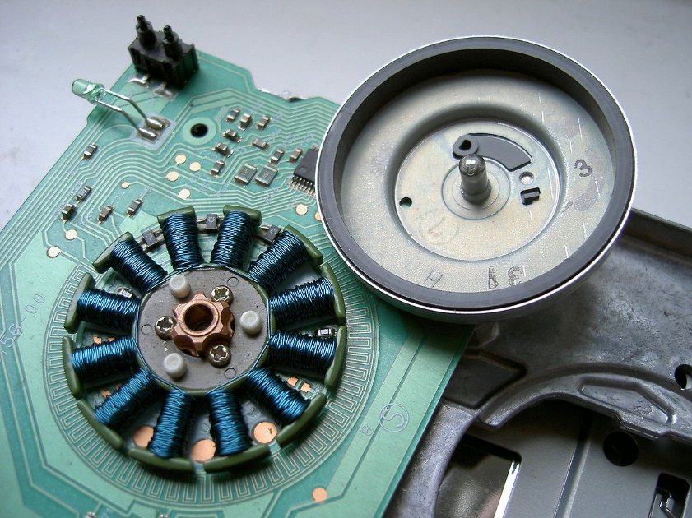Regardless whether shunt or series, when both motors are designed with brushes and commutators they suffer the same disadvantage – the relatively high wear and tear of these components. There was no avoiding this until the 1970s when semiconductor technology was developed. In a brushless DC motor, there are no brushes to achieve the necessary reversal of current/magnetic field. Electrical transistors (the semiconductor technology) perform the reversal instead.

In a brushed motor the rotor (rotating part) is the armature coil and the stator (stationary part) is the permanent magnet or field coils. A brushless motor reverses these roles. The armature coils remain stationary in the centre while a permanent magnet rotates around the outside. This reduces the inconvenience of designing a method to drive a current through a rotating armature without tangling the wires.

As the rotor rotates it triggers the transistor switches which rapidly change the direction of the current in the armature windings. Maximum speed is still reached when the back emf of the armature equals the supplied emf but speed can easily be controlled by adjusting the supplied voltage. This motor is also quieter than the brushed types because most of the noise of a motor comes from the rotation and grinding of the commutator against the brushes.

1. State the defining components of a DC brushed motor and one place where these motors are used. (2 marks)
2. State the name of the conductor windings used as an electromagnet in a large motor.

(1 mark)

1. Compare the difference in the construction of a shunt wound motor and a series wound motor. (2 marks)
2. Explain why the components in a brushed motor have high wear and tear. (2 marks)
3. Explain, referring to physical principles, why increasing the resistance in the field coils of a shunt wound motor results in:
   1. A decrease in the magnetic field strength. (2 marks)
   2. An increase in the speed of the motor. (3 marks)
4. By referring to formulae in the Formulae and Data Booklet and physical principles, show why torque of a series wound motor is proportional to the square of the current supplied, as suggested by the article. (Note: you are **not** required to derive a new formula) (3 marks)
5. Describe how a brushless motor overcomes the biggest disadvantage shared by all brushed motors. (3 marks)

**End of Questions**

**Additional working space**

**Additional working space**

**Spare grid for graph**

prac exam youngs mod 10 by 10

**End of examination**

**Acknowledgements**

**Question 16**

Trebuchet Diagram

CC0 Public Domain

<https://openclipart.org/detail/48559/trebuchet>

Castle Diagram

CC0 Public Domain

<https://openclipart.org/detail/24916/castle>

Question 20

# *The Universe Has A Speed Limit, And It Isn’t The Speed Of Light,*

<https://medium.com/starts-with-a-bang/the-universe-has-a-speed-limit-and-it-isnt-the-speed-of-light-543b7523b54f>

Used with permission from Ethan Siegel

Question 21

Small DC motor image

User Jfer91

CC BY SA 3.0

<https://en.wikipedia.org/wiki/Brushed_DC_electric_motor#/media/File:Motor_internals.JPG>

Question 21

Field and motor windings image

User Haade

CC BY SA 3.0

<https://en.wikipedia.org/wiki/Brushed_DC_electric_motor#/media/File:Serie_Shunt_Coumpound.png>

Question 21

Brushless motor

User Sebastian Koppehel

CC BY SA 3.0

<https://en.wikipedia.org/wiki/Brushless_DC_electric_motor#/media/File:Floppy_drive_spindle_motor_open.jpg>